**Antique Gold Small Sun Convex Mirror**

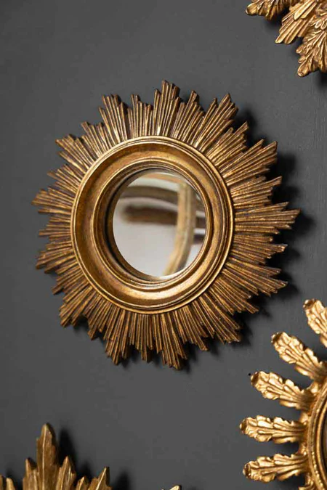The Antique Gold Small Sun Convex Mirror exudes timeless elegance with its radiant sun-inspired design. Featuring a delicately crafted antique gold frame, the mirror's convex shape adds a dynamic visual effect, enhancing the reflection and light in any room. Its smaller size makes it a perfect accent piece for a variety of spaces, from entryways to living rooms, while the sun motif symbolizes warmth and vitality. The intricate detailing of the gold frame adds a touch of luxury and sophistication, making this mirror a standout decorative element that effortlessly blends with both traditional and modern interiors.